--1. Find out which product created more revenue in the month of October.

CREATE VIEW vw_Total_Revenue_Oct

AS

SELECT DISTINCT i.item_name, MONTH(s.sale_date) AS sale_month, SUM(s.quantity * iu.unit_price) AS TotalRevenueOct

FROM Item_details i

INNER JOIN Item_unit_details iu

ON i.item_id = iu.item_id

INNER JOIN Sales_details s

ON iu.item_unit_id = s.item_unit_id

GROUP BY i.item_name, MONTH(s.sale_date)

HAVING MONTH(s.sale_date) = 10;

SELECT item_name, sale_month, TotalRevenueOct

FROM vw_Total_Revenue_Oct

WHERE TotalRevenueOct IN (SELECT MAX(TotalRevenueOct) FROM vw_Total_Revenue_Oct);

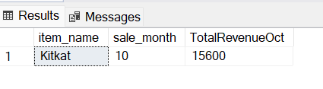

--2.Find out which product sold more in Amal Store in the month of October

CREATE VIEW vw_AmalStoreOct

AS

SELECT shop.shop_name, i.item_name, MONTH(s.sale_date) AS sale_month, SUM(s.quantity) AS TotalQuantitySold

FROM Item_details i

INNER JOIN Item_unit_details iu

ON i.item_id = iu.item_id

INNER JOIN Sales_details s

ON iu.item_unit_id = s.item_unit_id

INNER JOIN Shop_details shop

ON s.shop_id = shop.shop_id

GROUP BY shop.shop_name, i.item_name, MONTH(s.sale_date)

HAVING shop.shop_name LIKE 'Amal Stores' AND MONTH(s.sale_date) = 10;

SELECT shop_name, item_name, sale_month, TotalQuantitySold

FROM vw_AmalStoreOct

WHERE TotalQuantitySold IN (SELECT MAX(TotalQuantitySold) FROM vw_AmalStoreOct);

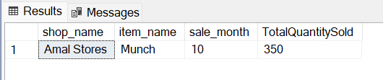

--3. Find out which all products crossed revenue more than Rs 10,000/- in the month of October

SELECT item_name, sale_month, TotalRevenueOct

FROM vw_Total_Revenue_Oct

WHERE TotalRevenueOct > 10000;

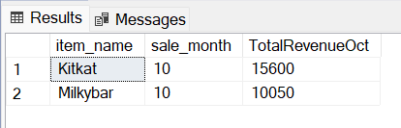

--4. Find out the shop which can be selected for the best store award of Nestle for the month of October based on revenue.

CREATE VIEW vw_Shop_Total_Revenue_Oct

AS

SELECT DISTINCT shop.shop_name, MONTH(s.sale_date) AS sale_month, SUM(s.quantity * iu.unit_price) AS TotalRevenueOct

FROM Item_unit_details iu

INNER JOIN Sales_details s

ON iu.item_unit_id = s.item_unit_id

INNER JOIN Shop_details shop

ON s.shop_id = shop.shop_id

GROUP BY shop.shop_name, MONTH(s.sale_date)

HAVING MONTH(s.sale_date) = 10;

SELECT shop_name, sale_month, TotalRevenueOct

FROM vw_Shop_Total_Revenue_Oct

WHERE TotalRevenueOct IN (SELECT MAX(TotalRevenueOct) FROM vw_Shop_Total_Revenue_Oct);

